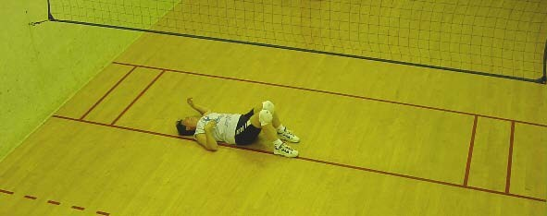
Do you have what it takes to be a National Champion?
Do you play well with others?

Come prove it at the Minnesota King/Queen of the Court National Championships.
Held at:
Life Time Fitness
1200 E Moore Lake Dr
Fridley, MN 55432

March 23 & March 24

Sign yourself up.

Call, text, or email Steve Fuhrman @ 612-581-7718 Wally@Ball.net

Entry Fee is $55 for a minimum of 12 hours of Wallyball play over 2 days.
Deadline to sign-up is March 19th.
Registration starts at 12:00. Player meeting at 12:30. Play starts at 1:00.

To Qualify:
- Players MUST know the basic rules of Wallyball
- Players MUST follow at least the guidelines for Intermediate overhead setting

Tournament format:

Day one:
- Players will complete a Wallyball skills survey before tournament starts
- All players will be put into a round robin and points will be recorded
- At the end of the day your lowest score will be removed

Based on scores and surveys, players will be put into divisions for day 2. Players will be informed on day 2 which division they are in

Day 2:
- Play for the titles. Awards given to top players in each division
- At the end of the day your lowest score will be removed. Highest average score per game wins
- Senior awards per division will also be awarded. The age divisions are defined using the National Seniors Games Association recommendations: 50-54; 55-59; 60-64; 65-69; 70-74; 75-79; 80-84; 85-89; 90-94; 95-99; and 100+
- The player who finishes in last place will also get an award

