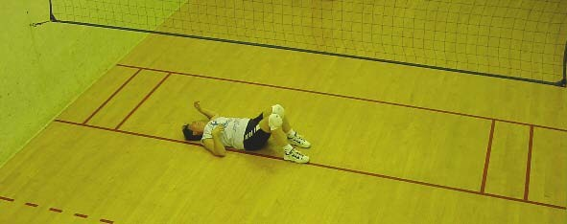
Do you have what it takes to be a National Champion?
Do you play well with others?

Come prove it at the Minnesota King/Queen of the Court National Championships.
Held at:
Life Time Fitness
1200 E Moore Lake Dr
Fridley, MN 55432

March 14th

Sign yourself up.

Call, text, or email Steve Fuhrman @ 612-581-7718 Wally@Ball.net

Entry Fee is $40

Deadline to sign-up is March 10th to be guaranteed a T-Shirt.
Awards will be based on entries on this date. Dead last gets an award.
Senior awards will be presented IF they complete the tournament.
Entries accepted until 3/13 @ 6 PM.

Player registration starts at 12:00. Player meeting at 12:30. Play starts at 1:00.

- Players MUST know and follow the basic rules of Wallyball
- Divisions are OPEN, Advanced 1 and 2, Intermediate

Tournament format:
- All players will be put into a round robin and points will be recorded
- Playing hours will be about 5-6 hours depending on number of players.
- At the end of the day your lowest score will be removed

Highest average points scored per game will win.

Other awards will be handed out.

Sanctioned by the Wallyball Information Network(WIN!)

