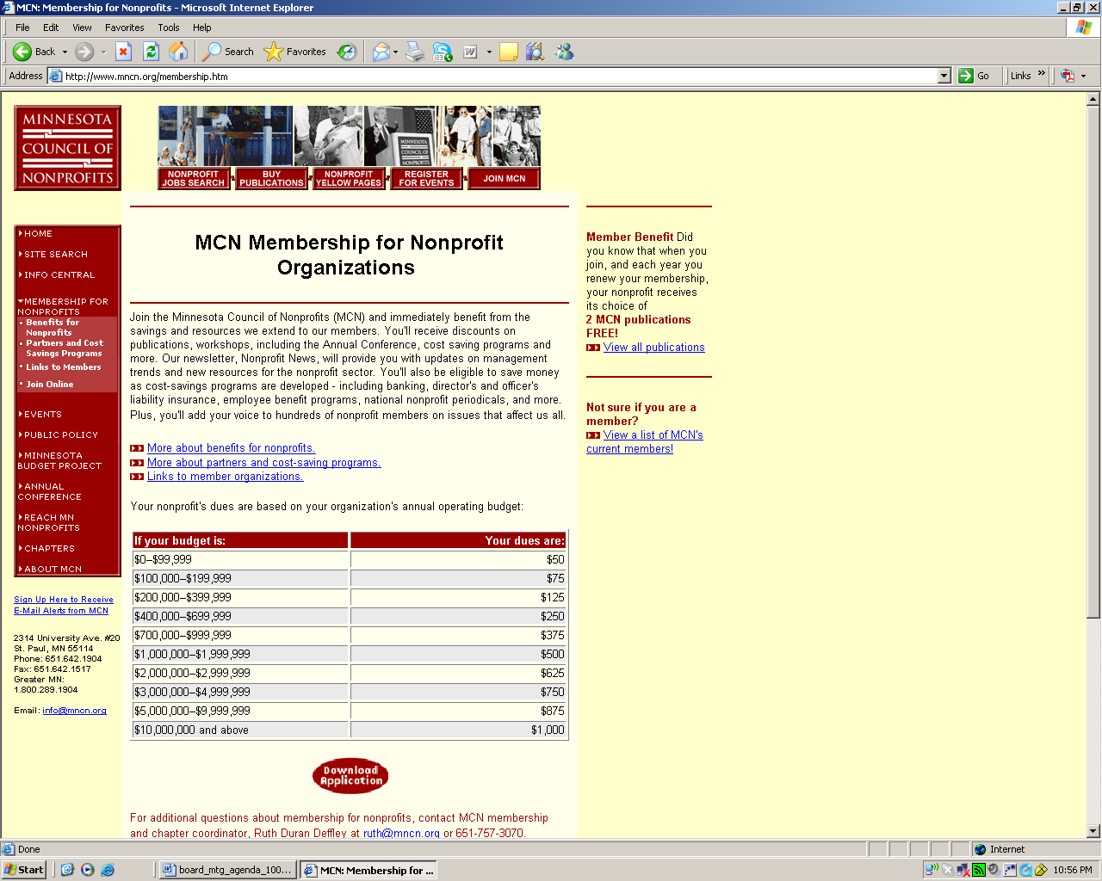
2008 - 2009 WIN! Wallyball Tournament Schedule

Oct - Nov, 2008
Top of the Heap Tournament - Open House
Capital Racquet and Fitness Center

December 6, 2008
Combined Age Triples Tournament
White Bear Lake Sports Center and Armory - Minnesota

January 10, 2009
2nd Annual Combined Age Triples Tournament
Eldridge Rec and Fitness Center - Iowa

February 2009
Triples FUN Tournament
White Bear Lake Sports Center and Armory - Minnesota

February 2009
Gladiator of the Coliseum
Coliseum Racquet Club - Michigan

March 6,7,8 2009
4th Annual Iowa State Tournament
Eldridge Rec and Fitness Center - Iowa

March 2009
3rd Annual Ohio Winter Bash
Genesis Lifestyle and Fitness Center - Ohio

March 27,28,29 2009
27th Annual Minnesota State Tournament
Central Courts - Minnesota

April 5, 2009
Masters Wallyball Tournament
LifeTime Fitness - Eagan - Minnesota

April 2009
THE AMERICAN CUP WALLYBALL CHAMPIONSHIP
Zodiac Health Club - Michigan

May 2,3 2009
1st Annual North Dakota State Tournament
Capital Racquet and Fitness Center

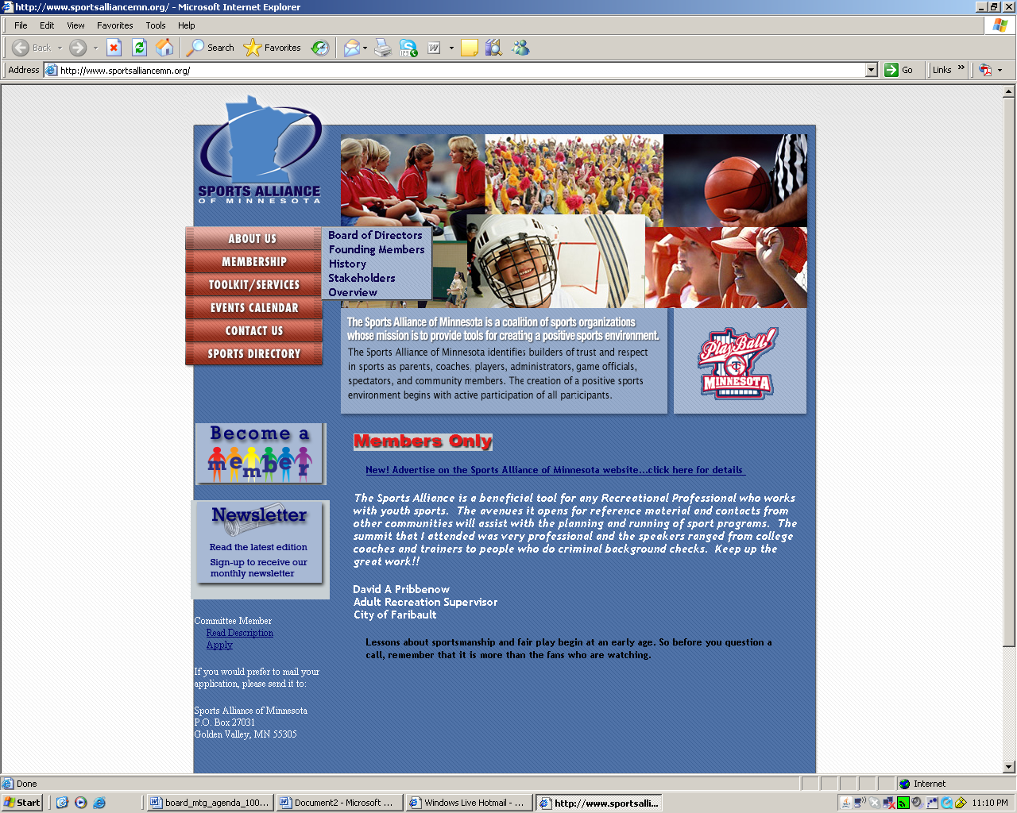

About Us
The Sports Alliance of Minnesota is a coalition of sports organizations whose mission is to provide tools for creating a positive sports environment.

The Sports Alliance of Minnesota identifies builders of trust and respect in sports as parents, coaches, players, administrators, game officials, spectators, and community members. The creation of a positive sports environment begins with active participation of all participants. The following outlines the key components needed to assure a positive sports environment. All the participants need to work in unison towards their objectives and goals in order to build a positive sports environment:
Objectives
- promotes fun, participation, and competition for the athletes.
- develops strong personal character traits.
- fosters healthy lifestyles.
- encourages sportsmanship.
- believes in ethical behaviors of players, coaches and parents.
- creates a safe environment.
- requires the involvement of everyone in the betterment of the community.
Goals
  - To have all activities of the team conform to the mission and objectives of the program.
  - To teach good sportsmanship to players, coaches, spectators, and parents.
  - To teach life skills and character development to the participants.
  - To train officials who will ensure fair play, sportsmanship and a safe environment.
  - To educate parents, players, and coaches on the rules of the game.
  - To educate parents on how to be a good role model for their children.
  - To promote those teams and participants who decide to follow the program.
  - To educate the coaches on the mission statement, basic coaching skills, how to work with parents, and how to establish/enforce the rules.
  - To evaluate and assess the program through surveys to coaches, players, and parents.
  - To commit to the betterment of their community by giving of their time and resources

