WIN! Activities between March 16, 2008 and April 12, 2016

May 3, 2008

Lori & Steve went to Bismark, ND to meet with representatives from their local wallyball league. They would like to be involved in a tournament with Minnesota players and visa versa.

June 17, 2008

Lori Ellsworth is elected for a 2nd term as President/Chairwoman of the Wallyball Information Network (WIN!) for a term of 3 years..

Question
I accept the appointment of Lori Ellsworth to a 2nd term of President / Chair- woman of the Wallyball Information Network (WIN!)

Responses
Choices | Votes | % | 1 reply
Yes, but she needs to buy dinner | 5 | 83
No | 1 | 16

July 9, 2008

Pete Sharbo is elected as a new member of the WIN! Board of Directors for a term of 3 years.

Question
Do you accept Pete Sharbo as a member of the WIN! Board of Directors?

Responses
Choices | Votes | % | 1 reply
Yes | 5 | 100
No | 0 | 0

July 21, 2008
Steve Fuhrman set up Board Members with option to receive WIN! daily summary or all individual e-mail messages.

July 31, 2008
General Information on WIN! Board terms
When Board terms expire ( based on 3 year term)
Michael – Feb 2009
Scott – Aug 2008
Steve – Jan 2011
Pete – June 2011
Bill – May 2009
Lori – June 2011
Lynne – March 2011
George - September 2009

September 29, 2008
Bill Reedy voted as new Vice President of WIN!
----- Forwarded Message -----
From: "Yahoo! Groups Notification" <notify@yahoogroups.com>
To: wally@ball.net
Sent: Thursday, September 25, 2008 11:53:37 PM (GMT-0600) America/Chicago
Subject: Poll results for wallyball-info

The following wallyball-info poll is now closed. Here are the final results:

POLL QUESTION: Should Bill Reedy be the next WIN! Vice President?

CHOICES AND RESULTS
- kyll? (Yes), 6 votes, 100.00%
- en (No), 0 votes, 0.00%

For more information about this group, please visit
http://groups.yahoo.com/group/wallyball-info

For help with Yahoo! Groups, please visit
http://help.yahoo.com/l/us/yahoo/groups/original/members/web/index.html

Your use of Yahoo! Groups is subject to http://docs.yahoo.com/info/terms/

October 5, 2008
Steve Fuhrman and Lori Ellsworth attended an open wallyball night at the Maplewood Community
Center Sunday night.
We were invited to come to talk to a group of volleyball and wallyball players, and to give tips on how to play.
We had a total of 16 players. We played 4's and 3's, as they had only 2 courts available. Overall it was a success and everyone had a great time.
Most of the players there were Intermediate, with a few advanced players.

November 25, 2008
Wallyball League update from Bob Gordon, WIN Director from Bismark, ND:
First of all, I hope this is going to the right people. If not, I'm sorry.
Second, I wanted to update everyone on what is happening in Bismarck.
We started our wallyball league. It is a short league, scheduled to fit in the gaps between volleyball seasons. So it will go from November 23 to Jan 11, 1009, with Sundays off for Thanksgiving weekend, Christmas and New Years weekend.
We broke it into two divisions, Beginners/Intermediate and Advanced. Unfortunately we only have two teams signed up for the B/I and four for Advanced (three now since my partner is out for awhile after pulling her hammy pretty bad while playing yesterday). One major reason I have heard for people not signing up is it conflicts with their watching
football. Hopefully my next league (starting in March) will be better. I watched the B/I games and was pretty impressed. All of the players knew how to pass the ball and there was no carrying etc. Just a lack of knowledge on setting up the ball and playing off the walls. I'm hoping to get them to show up for some matches after the advanced league. All
the advanced players were excited about playing with new players. Maybe this will help get the ball rolling.
So it sounds like this seasons league is a bust, but we'll keep playing and having fun. We have some interest and I am hoping to build off that for the next season.
I'll keep you posted.
Bob Gordon
(the players there were Intermediate, with a few advanced players.)

December 30, 2008

Steve Fuhrman began a WIN! message/meeting page on Yahoo Group for Wallyball:

All WIN! board meeting info will be posted here.
http://www.wallyball-info.com/WIN_BOD_INFO_PAGE.html

This web page is also linked from the top graphic on our main web page.

Feel free to share this info with anyone.
Steve

January 15, 2009

Steve Fuhrman launched new WIN! home page/website:
Our website rework has been launched!
www.wally.ball.net
Work is on-going behind the scenes to add more features.
Please send me comments or corrections.
Steve

February 17, 2009
Tournament Committee came up with clarification on Player Skill Levels and guidelines:
From the Tournament Committee (Lori, Bill, George, Steve).
Player guidelines for each skill set.
------------
All players will follow these guidelines. Men & women will be in the same group.....
Player skills:
In order to determine what division a player should play in, WIN! will use the following to rate a player.
1) The ability to get to a ball and get it in the air.
2) Setting (bumping or hand setting.but do not need to do both). You can set to a specific spot.
3) Ball placement accuracy
4) Normal Serving
5) Advanced Serving (Spin)
6) Passing - you can pass the ball accurately (To a specific spot)
7) Receiving the Serve
8) Receiving Spikes
Please note that how hard you hit the ball or how well you can block are not rated as "skills".
Anyone can hit the ball hard and have no idea where it is going....Any tall player can stand at the net and block.
----------
Each division has their own specific rules (See http://wallyball.homestead.com/Wallyball-Divisions.html)
An OPEN player has a 80%- 100% accuracy in their skill set (when you play against players at your same level).
An ADVANCED player has a 50%-80% accuracy in their skill set.
An INTERMEDIATE player has a 20%-50% accuracy in their skill set.
Below 20% - A player is a beginner or a RECREATIONAL player.
----------------
ALSO,
Tournament Directors will try to stop teams from "playing down".
This idea has been tested at the Iowa State Tournament the past 2 years.
For example, The Intermediate division is for Intermediate players ONLY. Advanced and open player cannot play in that division.
Another example, in a triples tournament, an OPEN triples team wants to play advanced. They would be allowed to play, but only as a doubles team.
These guidelines will be added to our Tournament Guidelines manual in the near future.
Ask a Tournament Director for more details.

February 17, 2009
Announcement for 2009 MN State Wallyball Tournament along with flyer:
Please see http://www.wallyball-info.com/Wallyball_Tournaments.html for more details.

March 23, 2009
Link set up for tracking which players signed up for 2009 MN State Wallyball Tournament
To see who's playing.... http://www.wallyball-info.com/Tournament_Signup.html
This page is updated a few times each day....

March 27, 2009
Day 1 of 3 for 2009 MN State Wallyball Tournament

March 28, 2009

WIN! Board Meeting scheduled for this evening after MN State Men's Triples event and before the Snowbirds take the court.
Day 1 of 3 for 2009 MN State Wallyball Tournament

Got any more material to add to the log between March 2009 and October 2009??

September 26, 2009
George Schneider 3-year term as Secretary expires.

October 22, 2009

WIN! Board Meeting scheduled for this evening after open Wallyball at Central Courts at Steve & Lori's home.

October 22, 2009

Michael Schroeder nominated for a 2nd term as Treasurer. Nominations will be accepted for 2 more weeks before board vote is held for this position.

October 22, 2009

George Schneider nominated for a 3rd term as Secretary. Nominations will be accepted for 2 more weeks before board vote is held for this position.

November 21, 2009

Annual Turkey Tournament held at Central Courts was well attended by 23 people. Top points winner - Steve Davis; awards given out for Highest, Lowest and 2 mid-tier average point totals.

November 21, 2009

WIN! Letterhead introduced by President Lori. Will be revised for acceptance at our next board meeting on 1/9/2010.

December 5-6, 2009

Northern Exposure "barnstorming" tour through Wadena and Detroit Lakes by Steve, Lori, Scott and George. Turnout in Wadena was light, which was understandable with such short notice (2 days). Detroit Lakes had several interested players who joined us on one of the 2 courts set up. Mike Schmidt and his brother (both from Perham) joined us, as they could not make it to Perham the day before.

January 2, 2010

New Years 'Fun' tournament held at Central Courts. Event was very well attended by 30 people. Format was mixing all levels within randomly selected teams. There was also an Advanced/Open Challenge court set up for a few matches. Many of the players were in the Intermediate category, with a few Beginners tossed in. Steve F. provided a "tips & skills" session on Court #2 for most of the day.

Overall the event was well-received with desire to do something like this again (which was later scheduled for Saturday, February 6 at Central Courts).

January 8, 2010

Combined Age Tournament in Eldridge, Iowa postponed due to poor (snow) weather. Rescheduled for January 23rd.

January 10, 2010

Michael Schroeder nominated and reelected to three year term to serve as Treasurer.

January 15, 2010

George Schneider nominated and reelected to three year term to serve as Secretary.

January 23, 2010

Combined Age Tournament held in Eldridge, Iowa.

February 6, 2010

Combined Age Tournament announced for February 20 to be held at White Bear Lake Sports Center (MN).

February 12, 2010

Steve Fuhrman recommended setting up a non-member account for WIN! Discussion Board for Rule Changes forum. This would allow non-members of WIN! Yahoo Group to participate.

February 20, 2010

Combined Age Tournament held at White Bear Lake Sports Center (MN).

March 5, 6,7, 2010

5th Annual Iowa State Wallyball Tournament held at Eldridge, Iowa.

March 15, 2010

Steve Fuhrman is working with a contact in Portland to help them set up a Wallyball league.

March 26, 2010

King/Queen of the Court - 28th Annual Minnesota State Wallyball Tournament held at White Bear Lake Sports Center (MN). For winners of the event, contact your WIN Secretary.

March 27, 2010

Men's Triples - 28th Annual Minnesota State Wallyball Tournament held at White Bear Lake Sports Center (MN).

March 28, 2010

Co-Rec Triples - 28th Annual Minnesota State Wallyball Tournament held at White Bear Lake Sports Center (MN).

May 17, 2010

During attempt to file Minnesota 990-N for WIN! as a non-profit entity, learned from the IRS that WIN! had not been issued an Employer Identification Number (EIN). Lori/Steve will request an EIN shortly.

May 19, 2010

Employer Identification Number (EIN) of 20-4372980 issues to WIN by IRS.

May 24, 2010

Steve Fuhrman is working on a Wallyball instructional program for kids under 13.

May 25, 2010

Steve Fuhrman is working with a group interested in setting up a formalized Wallyball league in Florida. The group consists of over 100 players. They play in a unique court situation with chain link fence as part of the walls and a partially open ceiling. They would like to play 6 players per team with recreational rules. The current league setup structures would need to be modified to accommodate this group's needs.

July 30, 2010

Steve Fuhrman updated the board with the following Completed and Pending activities to date:
It's been a busy, but productive summer for wallyball.

Completed tasks....

1) A wallyball league for 6's has been setup in Florida using outdoor courts.

2) WIN! developed rules and playig guidelines for teams up to 6 players.

3) Win! helped setup a charity tournament (location unknown) for a church.

4) Helped setup league in Oregon.

5) Created wallyball programs for kids.

In the works:

1) Talking with Tachikara to make our own wallyball..... just thinking ahead.

2) Researching the possibility of working with companies to make and sell our
own wallyball net.

3) Putting the final touches on the possible new/additional rules to rulebook.
This will be to a WIN! BOD vote soon.

4) Finishing new rulebook and having it available on-line before 1/1/2011.

5) Working with players in Kansas City to start league.

6) Creating a Wallyball program for colleges.

7) Setting up open houses in MN, WI, and IA for the next year. More later on this.

September 1-9, 2010

George conducted Wallyball League Survey via Zoomerang to 120 potential participants by e-mail. Total of 22 (18%) responded, but the numbers were not enough to warrant a league. We will be offering 2 nights of play at Central Courts for Fall/Winter 2010-2011 - Tuesday (Advanced) and Thursday (Intermediate). Will also be play at Radisson (Plymouth, MN) on Wednesday nights; level of play has yet to be determined.

September 10, 2010

Lori announced WIN! Board Meeting to be held on Monday, September 13 at Steve's home at 8:00 pm.

September 20, 2010
Update this document to reflect current Board Member Terms, positions and expirations.
Member Name | Board Position | Term Expiration Date
Lori Ellsworth | President | June 2011
Bill Reedy | Vice President | September 2011
George Schneider | Secretary | January 2013
Michael Schroeder | Treasurer | January 2013
Scott Fuhrman | Board Member | September 2011
Lynne Nelson | Board Member | March 2011
Pete Sharbo | Board Member | June 2014
Bob Gordon | Board Member | August 2011

September 24, 2010
Due to unforseen circumstances, Bill Reedy will be temporarily taking over Presidential duties starting Oct. 1. Please direct any matters related to President to Bill but please copy me too. I hope to be able to resume my duties early next year.

October 11, 2010

September 13 WIN! Board Meeting minutes posted on internal website.

October 21, 2010

QC Volleyball website in Iowa discontinued operation. This had been a resource for posting Iowa wallyball events.

December 8, 2010

New Rules proposals posted on WIN! Yahoo Groups for Board member discussion.

December 10, 2010

Turkey Tournament in Minnesota postponed due to heavy snowstorm. Will reschedule this event in January 2011.

January 15, 2011

Turkey Tournament in Minnesota held on this date at White Bear Lake Sports Center. 14 players participated

January 19, 2011

Bill Reedy announces the Iowa Combined Age tournament in Eldridge is being cancelled due to low player signup.

January 22, 2011

Bill Reedy to host WIN! Board Meeting. Remote users can participate via Skype.

November 1, 2011

WIN! conducted a Proposed Rules Change vote among board members after receiving input from various player suggestions.

1 proposed rule change ended in a tie. Question sent to the Rules Committee on how that tie should be broken. It was agreed that another vote should be done for the issue which ended in a tie. That 're-vote' would be sent just to the Executive Committee of 3.

December 6, 2011

Steve Fuhrman set up WIN! as a member of Techsoup (http://www.techsoup.org) which enables us to receive product donations as long as we are a registered 501c-3 organization. "At TechSoup, nonprofits and libraries can request and receive technology products donated by TechSoup partners, and they can find tech-focused content and community tuned to their needs. We're a nonprofit with a clear focus: to make it as easy as possible for other nonprofits and libraries to obtain and use the technologies they need to achieve their goals. As part of that mission, we provide access to over 400 products donated by more than 40 companies — including donor partners like Microsoft, Adobe, Cisco, Intuit, and Symantec.
We need to be a 501 C3 organization to take advantage of this program."

December 17, 2011

Triples Turkey Tournament held at White Bear Lake (MN) Sports Arena. Event was attended by 18 players of various skill levels. Rotating teams were created to determine individual point totals for each player. Turkey was awarded to the "winner" of the event by.

1st place: Steve F. - Cornish hen

8th place: Terry W. – Cornish hen

5th place: Tim N. – Cornish hen

12th place: Terri J. – Turkey

3rd place: Tom S. – Cornish hen

7th place: Jay C. – Cornish hen

18th place: Marlin M. – Cornish hen

Hens given away during a drawing: Andy F. and Nathan D.

February 15, 2012

Scott Fuhrman reelected to the WIN! Board Of Directors. Term to expire February 2015.

Lori Ellsworth reelected to the WIIN! Board of Directors as President. Term to expire February 2015.

Bill Reedy reelected to the WIIN! Board of Directors as Vice President. Term to expire February 2015.

Vicky Harbour elected to the WIN! Board of Directors as Treasurer. Term to expire February 2015.

February 18, 2012

WIN! sponsored MN Combined Age Tournament at White Bear Lake Sports Arena. 12 teams competed in the event with an Upper and Lower Bracket division winner.

February 20, 2012

Poll started for potential new board member, Oli Mechtel.

February 29, 2012

Oli Mechtel voted in as newest board member. Term to expire February 2015.

March 3, 2012

WIN! Board Meeting held in Davenport, IA during Iowa State Wallyball Tournament.

March 29, 30, April 1 2012

Minnesota State Wallyball Tournament held at Lifetime Fitness club in Fridley, MN. WIN! sponsored the event and LTF was the host. Events went relatively well with few issues.

May 19, 2012

WIN! Board Meeting held at Steve & Lori’s home in Coon Rapids, MN.

October 28, 2012

Updated this document to reflect February 15, 2012 Board Member reelections for Bill Reedy and Lori Ellsworth.

November 15, 2012

WIN! Board Meeting held at Steve & Lori’s home in Coon Rapids, MN.

January 12, 2013

WIN! sponsors Turkey Tournament at White Bear Lake Sports Arena (White Bear Lake MN). Event was attended by 26 players.

January 19, 2013

Iowa Combined Age Tournament held in Eldridge, IA.

January 20, 2013

WIN! Board Meeting held at Eldridge, IA after Iowa Combined Age Tournament held yesterday.

February 23, 2013

Minnesota Combined Age Triples Tournament held at White Bear Lake Sports Center in White Bear Lake, MN.

March 8-10, 2013

Iowa State Wallyball Tournament held at Eldridge, IA.

March 22-24, 2013

Minnesota State Wallyball Tournament held at Lifetime Fitness Center in Fridley, MN

March 24, 2013

WIN! Board Meeting held at Lifetime Fitness (Fridley, MN) prior to the Coed Triples event.

April 13, 2013

Spring Fever 2013 Fun Tournament held at White Bear Lake Sports Center at White Bear Lake, MN.

January 21, 2014
George set up Lifetime Fitness (Fridley, MN) Facebook page specific to LTF Wallyball (https://www.facebook.com/LTFFridleyWallyball/) with link to WIN! site. This was an effort to help increase awareness at Lifetime (LTF) for its members. The main LTF Facebook page is https://www.facebook.com/lifetimefridley. (The old web-based ‘MyLT Groups’ was taken down by LTF in late 2013.)
So far, activity/response to webpage is very low (not being promoted by Facebook).

March 28-30, 2014
MN State Tournament held at Lifetime Fitness (Fridley, MN) for King of the Court (Friday), Men’s Triples (Saturday) and CoEd Triples (Sunday). The King of the Court event was broken into separate divisions (Open and Advanced) where round robin play was limited to the division. 3-day event went well with no issues of concern.

March 30, 2014
WIN! Board Meeting held at Lifetime Fitness (Fridley, MN) prior to CoEd Triples event play.

April 13, 2014
WIN! Board Member current terms are as follows with George’s expiring last January and Pete’s coming up in June 2014.
Board Member Name | Officer Description | Term Expires | Home Phone | Cell Phone | E-mail Address
Lori Ellsworth | President | February 2015 |  | 651-308-4560 | president@wallyball-info.com
Bill Reedy | Vice President | February 2015 |  | 563-370-5464 | billr@rsipumps.com
George Schneider | Secretary | January 2013 | 763-420-8027 | 763-226-4677 | dukewolves@comcast.net
Pete Sharbo |  | June 2014 | 651-686-9282 | 651-324-8917 | pete.sharbo@thomsonreuters.com
Lynne Nelson |  | January 2015 |  | 612-710-2129 | nels1847@umn.edu
Scott Fuhrman |  | February 2015 | 763-786-7868 | 612-804-7102 | masterrunt29@gmail.com
Steve Fuhrman | Executive Director | No term |  | 612-581-7718 | steve_fuhrman@msn.com
Vicky Danielsen | Treasurer | February 2015 | 563-320-0587 | 563-320-0587 | vjdanielson427@gmail.com
Oli Mechtel |  | February 2015 | 763-561-1905 | 763-639-7893 | Oliver.Mechtel@bestbuy.com

October 25, 2014
WIN! Board Meeting held at Steve & Lori’s home in Coon Rapids, MN.

October 25, 2014
Created ‘Wallyball Information Network Board Members.doc’ to track board member terms and contact info. Posted on WIN! page at Google Docs.

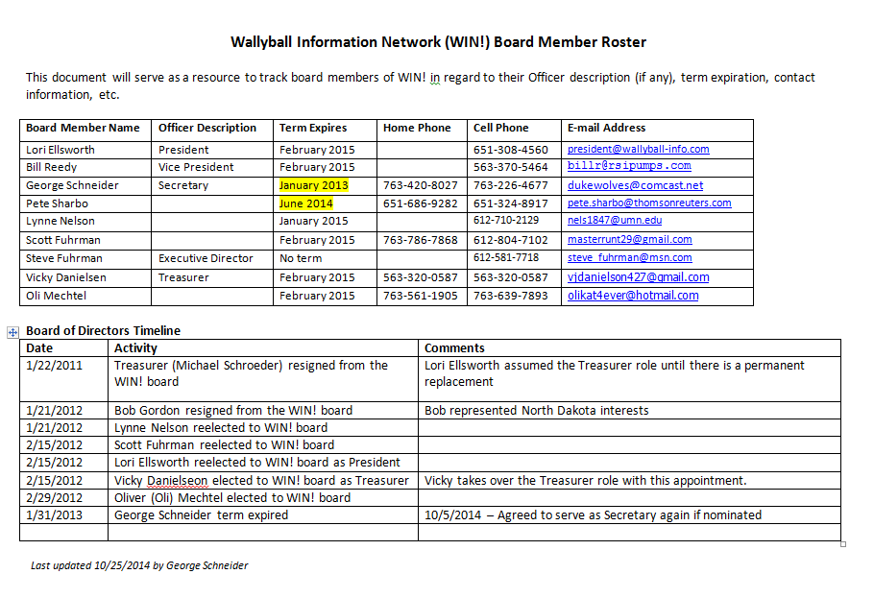

December 13, 2014
18th Annual Turkey Tournament held at Plymouth Creekside Athletic Club in Plymouth, MN.

January 16, 2015
Jason Kring will join the Wallyball Rules Committee and Carol Hunter will join the newly-formed Wallyball Media Committee.

January 21, 2015
Finalized plans for the MN Combined Age Tournament to be held at Lifetime Fitness in Fridley, MN on February 7, 2015.

January 24, 2015
Updated WIN! Board Members document to reflect current terms and contact information. (See below for details.)

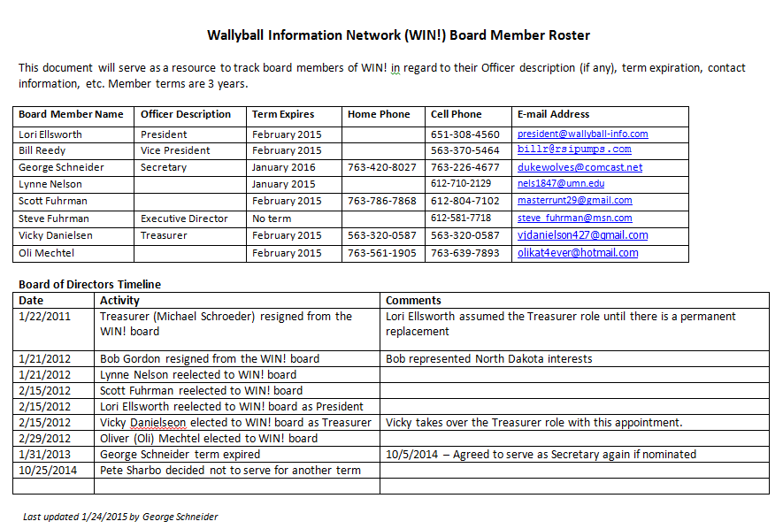

January 25, 2015
WIN! Board Meeting to be held in Davenport, IA after Iowa Combined Age Tournament on January 24.

February 7, 2015
Minnesota Combined Age tournament held at Lifetime Fitness in Fridley, MN.

February 27, 28 & March 1, 2015
Iowa State tournament held at Eldridge Rec & Fitness in Eldridge, IA for King/Queen, Men’s Triples, and CoEd Triples events.

March 27, 28 & 29, 2015
Minnesota State tournament held at Lifetime Fitness in Fridley, MN for King/Queen, Men’s Triples, and CoEd Triples events. King/Queen and CoEd events almost had to be cancelled due to few entries the week before the events. Tournament directors had to reach out to players to sign up so events would not be cancelled. All 3 events were held with enough players signed up for each.

March 29, 2015
WIN! Media Committee will have a $500 annual budget going forward. Previously, this committee had no budget since it did not exist until this year.
WIN! Rules Committee decided they did not need a budget since they have no expenditures at this time.

March 29, 2015
WIN! Board Meeting held at Lifetime Fitness in Fridley, MN prior to Minnesota State CoEd Triples event. All 5 current board members were present.
Previous board members Oli Mechtel, Scott Fuhrmann and Vicki Danielson decided to no longer serve.

March 29, 2015
WIN! determined will be using/recommending the Tachikara WB2000 blue/black/white Wallyball going forward. Will also make this the new standard at WIN! hosted tournaments.

December 6, 2015
WIN! Board Meeting held at Steve & Lori’s home. All 5 current board members were present (Bill remotely).

January 9, 2016
WIN! Board meeting minutes draft sent via e-mail to Board for review.

December 12, 2015
19th Annual Turkey Tournament held at Plymouth Creekside Athletic Club in Plymouth, MN.

January 23, 2016
9th Annual Iowa Combined Age tournament held at Eldridge Recreation & Fitness Center.

February 20, 2016
16th Annual Minnesota Combined Age tournament held at Lifetime Fitness in Fridley, MN.

March 4, 5 & 6, 2016
11th Annual Iowa State tournament held at Eldridge Rec & Fitness in Eldridge, IA for King/Queen, Men’s Triples, and CoEd Triples events.

April 1, 2 & 3, 2016
34th Annual Minnesota State tournament held at Lifetime Fitness in Fridley, MN for King/Queen, Men’s Triples, and CoEd Triples events. This was the largest turnout in years with over 100 unique participants.

April 3, 2016
WIN! Board Meeting held at Lifetime Fitness in Fridley, MN prior to 3rd day of MN State Tournament. All 5 current board members were present, plus committee members Jason Kring and Carol Hunter.

December 10, 2016
20th Annual Turkey FUN Tournament held at Plymouth Creek Fitness Center in Plymouth, MN. Attended by xx participants. Prizes awarded to randomly picked players.

January 14, 2017
WIN! Board Meeting held at Steve & Lori’s house in Coon Rapids, MN. Attended by ……..

