Wallyball Tournament Survey for Combined Age (2/9/08) Results as of 2/25/08

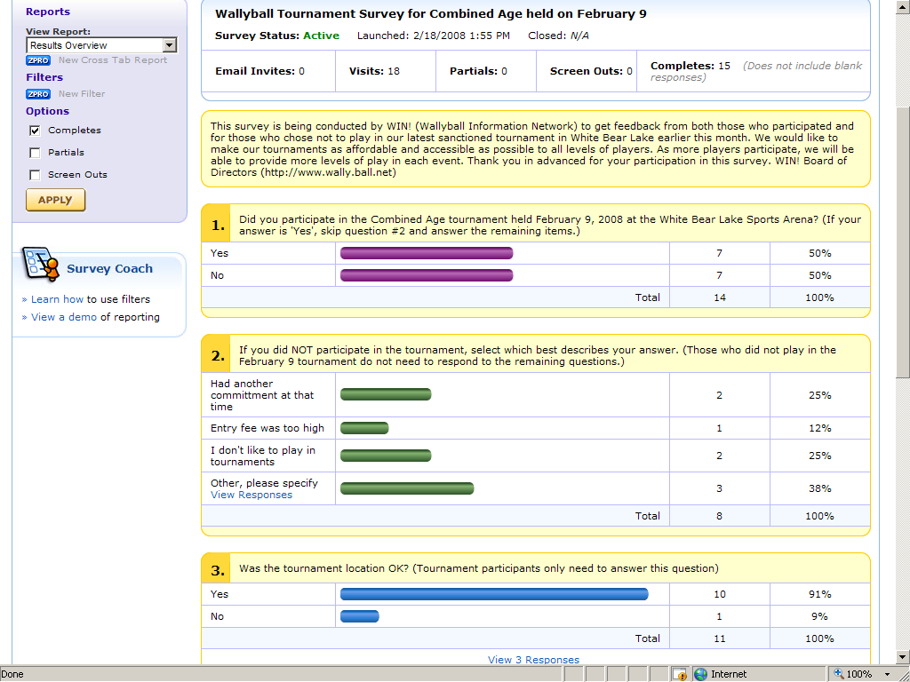
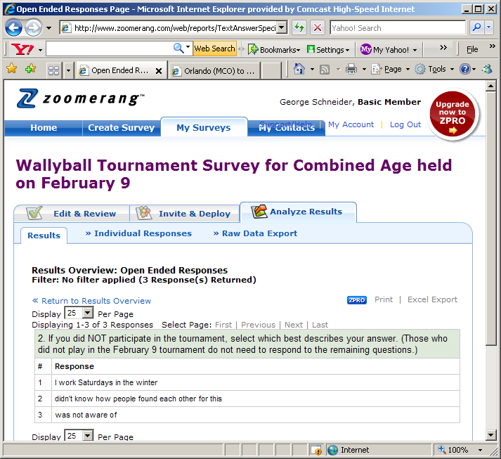

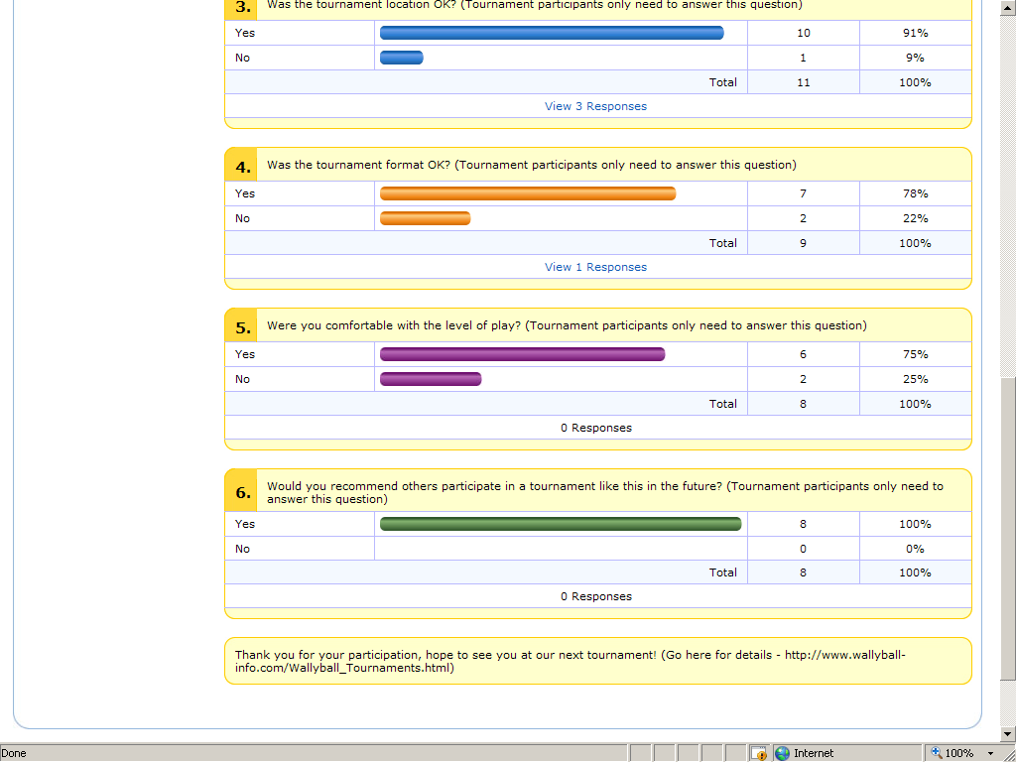

Overall summary

- 15 respondents out of total 101 invites (15%)
- 7 of the 21 individuals who signed up responded to the survey
- Most people (10 of 11) liked the location
- 7 of 9 (78%) respondents thought the tournament format was OK
- 7 of 10 (75%) were comfortable with the level of play
- 8 of 8 (100%) would recommend the tournament to others

Survey conducted from 2/18/08 through 2/28/08 by George Schneider

